PLP Class – Tellagami and Padlet
Presented by Michelle Kovacs
August 6, 2014

Part I: Tellagami

- What is Tellagami?
  - App that lets you create and share a quick 30-second video that is animated.
  - Has a limited, customizable avatar that allows you to record your voice
  - Finished product is called a “Gami”
- How can you use it in your classroom?
  - Pose a reading comprehension question from your shared reading.
  - Fluency – students read a 30 second portion of a story, listen to themselves and reflect.
  - Letter/sound recognition – Give each student a letter of the alphabet, have them take a picture of an object that begins with that letter to use as their background, and then record their voice telling what their object is, the letter it begins with and the sounds it makes…
  - Vocabulary – reading or content area based, where students discuss the word and its meaning.
  - Character analysis, pose a question about a character from a book, have students discuss the trait(s)
  - Biography/Autobiography
  - Explain the steps of a Math Problem
  - Ways we discussed in class:
    - ____________________________________
    - ____________________________________
    - ____________________________________
    - ____________________________________
    - ____________________________________

- So, how do you use Tellagami?
  - Open the app on the iPad.
  - It will open to an introductory page, click CREATE.
- It will open up to another window with a default character, along with an icon bar on the left, message icon in the center of the page (that looks like a talking bubble), and a preview button.
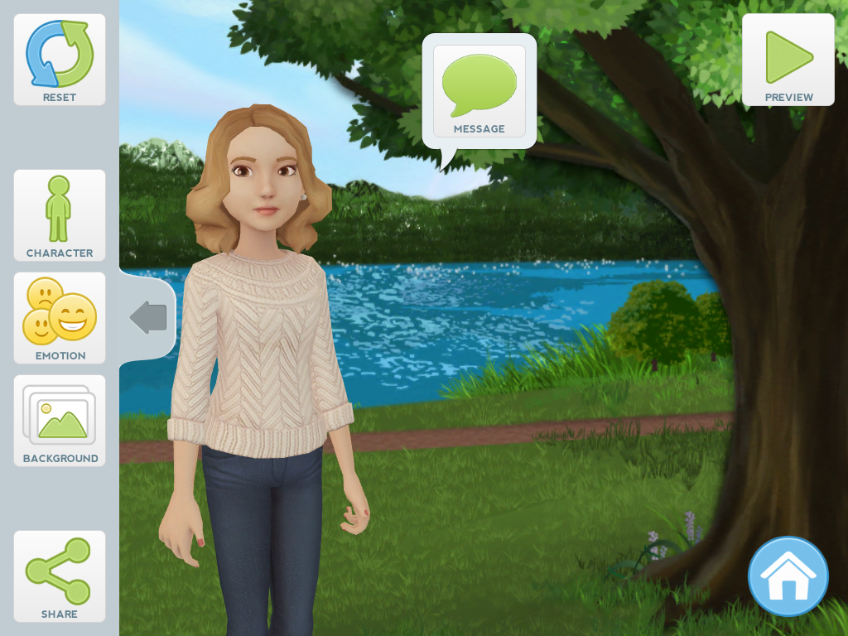
- The RESET icon is only if you want to start over.
- There are four main icons in the TOOL ICON BAR: CHARACTER, EMOTION, BACKGROUND and MESSAGE.
- The CHARACTER icon will allow you to customize your avatar. Click the icon and it will open up options on the right hand side of the page.
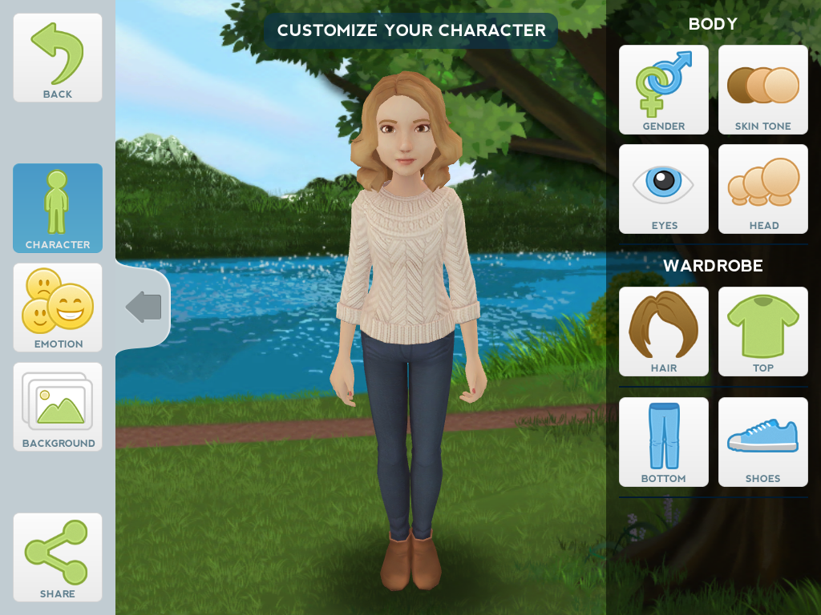
- You can change the GENDER, SKIN TONE, EYE COLOR, and HEAD SIZE of your avatar. There are a few choices for the color of the avatar’s HAIR, TOP, BOTTOM and SHOES. (There are more options in the app that can be purchased; in the free app, there are only a few choices, limiting the amount of time students can spend on a particular item.)
- Next, you can change the EMOTION of your avatar by clicking the EMOTION icon on the left side of the window.
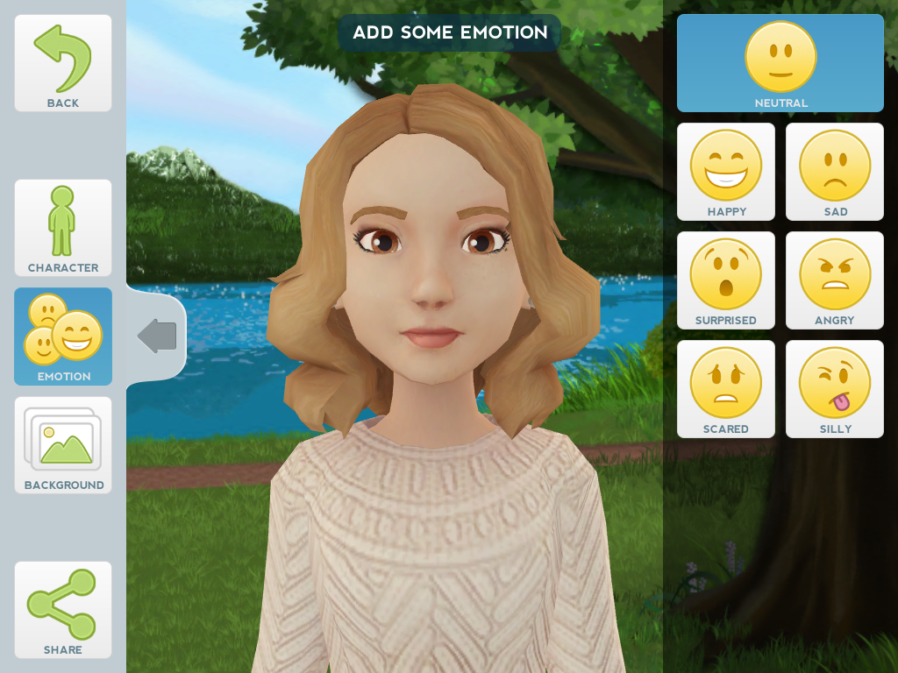
- The line above your avatar tells you where you are and what you can do in that particular window. (Add some emotion is on the previous screenshot.) Students can make their avatar happy, sad, silly, etc., to match what you have asked them to do.
- Next, you can change the BACKGROUND of where your avatar is located.
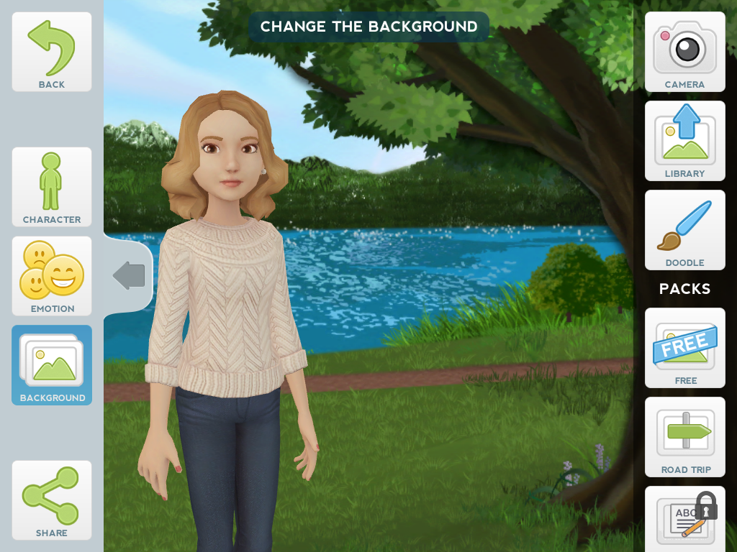
- You can use the preloaded “packs,” of backgrounds in the app, which are limited in the free version, or you can either take a photo or even use one from the camera roll already on the iPad.
- I would suggest having students do the VOICE (MESSAGE) last. Another tip would be to have them write what they plan to say PRIOR to recording. Students will need to speak into the speaker of the iPad or use earbuds that have the microphone with them (Apple earbuds have this.) In case they don’t like what or how they say their message, they can rerecord it as needed.
- Click on the CHARACTER icon to see the MESSAGE bubble pop up beside the avatar.
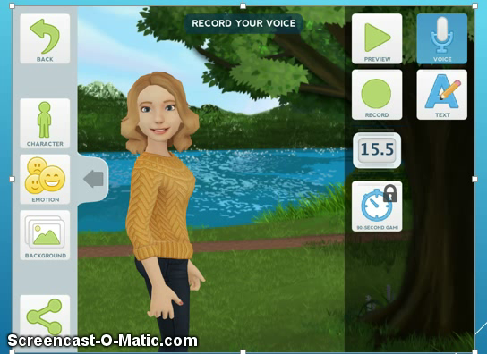
- Make sure students know to speak loud and clear into the iPad (near the power port) for a better recording. All they have to do at this point is click RECORD and begin talking. A STOP icon will appear once you have clicked RECORD and a timer will run. There is a 30-second limit in the free app. (If the app options are purchased, you can have students type in their text that will then allow them to pick a voice for their avatar, some with cool accents.)
- There is a PREVIEW play icon that allows you to preview what your video will look and sound like.
- Lastly, you will need to click SAVE. Then students can SHARE their Gami!
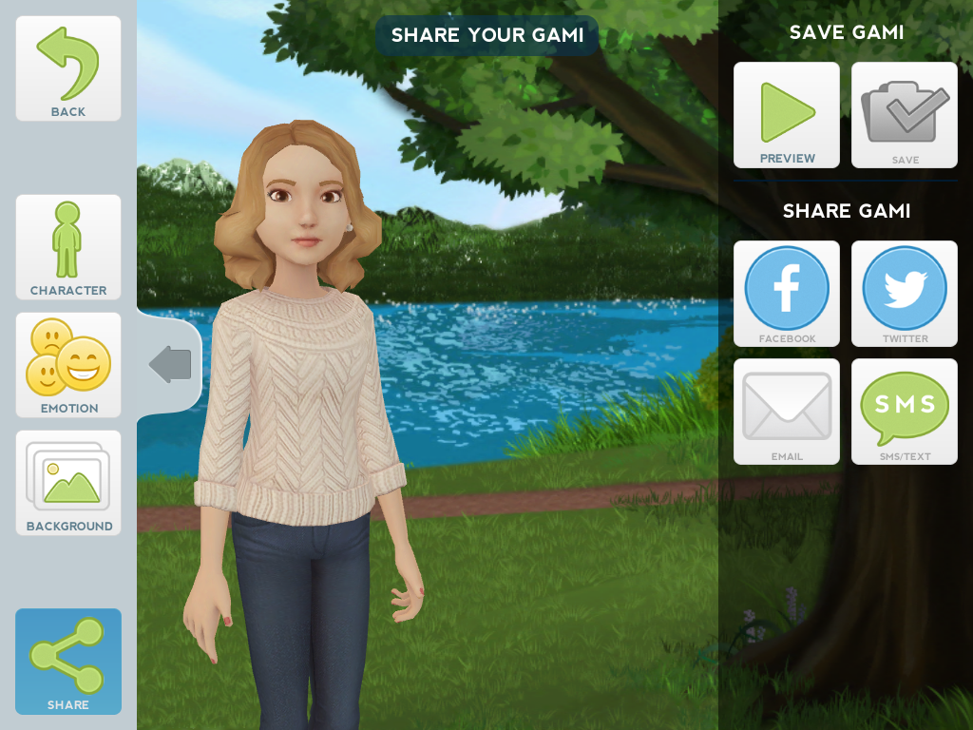
- Obviously, they cannot use the Facebook or Twitter options, and only the email option if it is enabled on the iPads. To share with the class, you only need the A/V Apple adapter and your speaker cord from your computer/Promethean hookup. The Gami can then be played and heard on your Promethean for your class to view.

  - Other Information;
    - You will need to see if your school librarian or CRS has the A/V adapters to show the Gamis directly from the iPads. (They are about $30 from Best Buy if you want your own.)

